**Projeto 01**

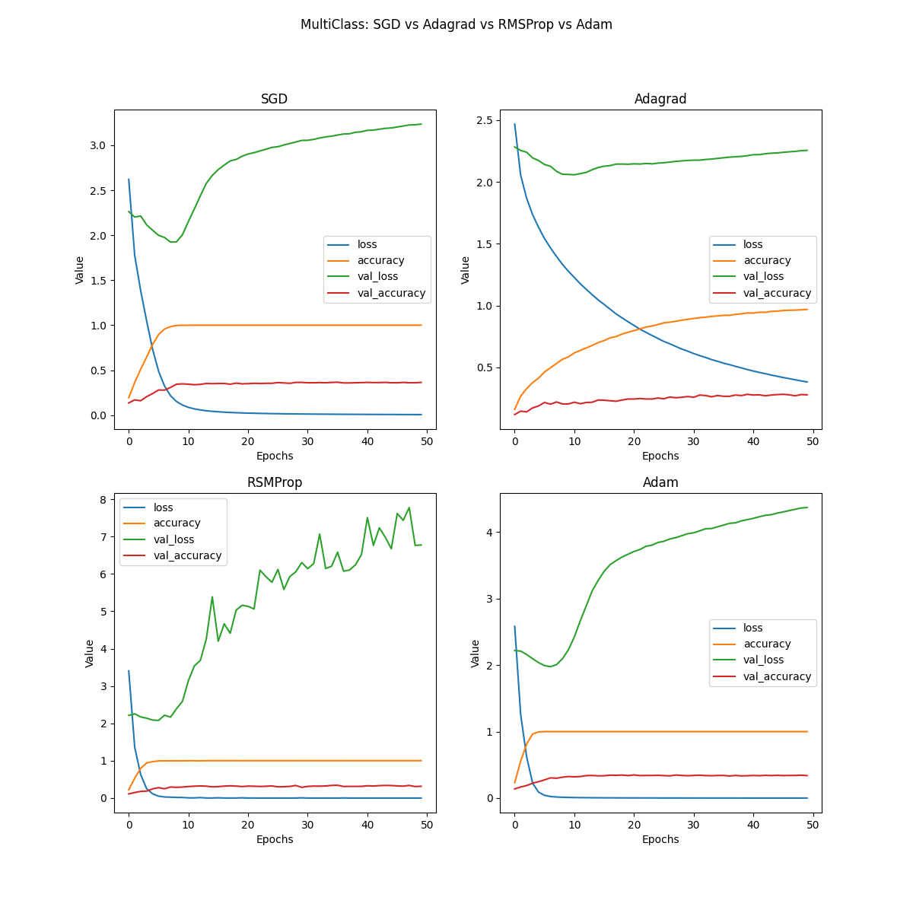Default options

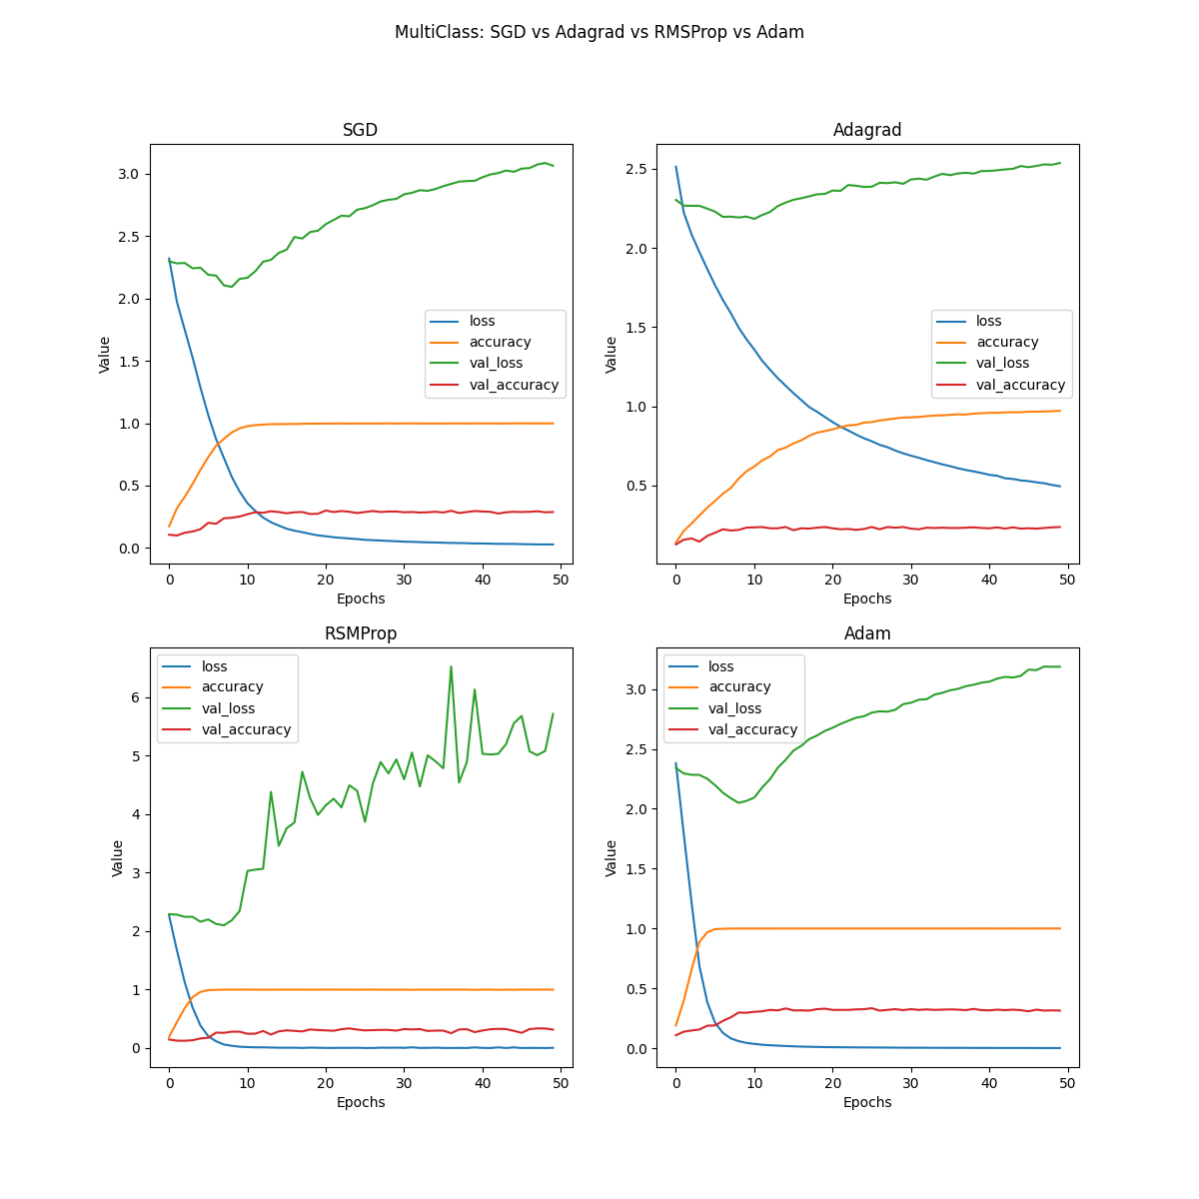Hidden layer 16 neurons

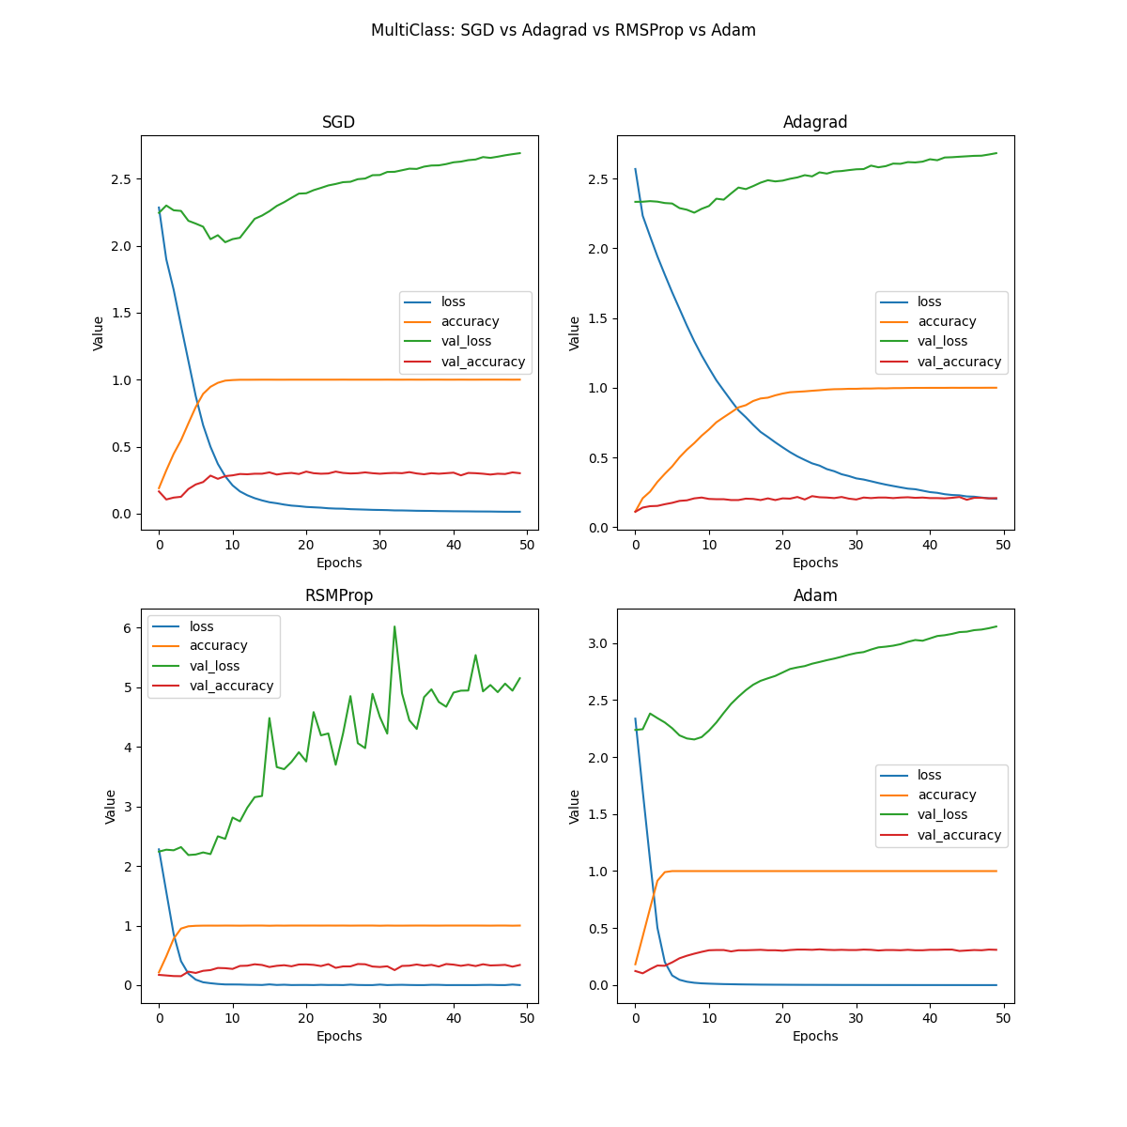

Hidden layer 32 neurons

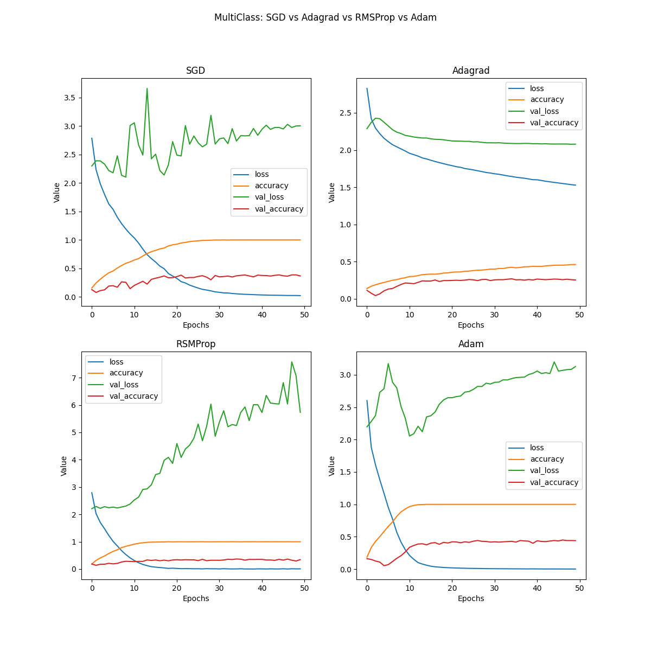1 additional conv

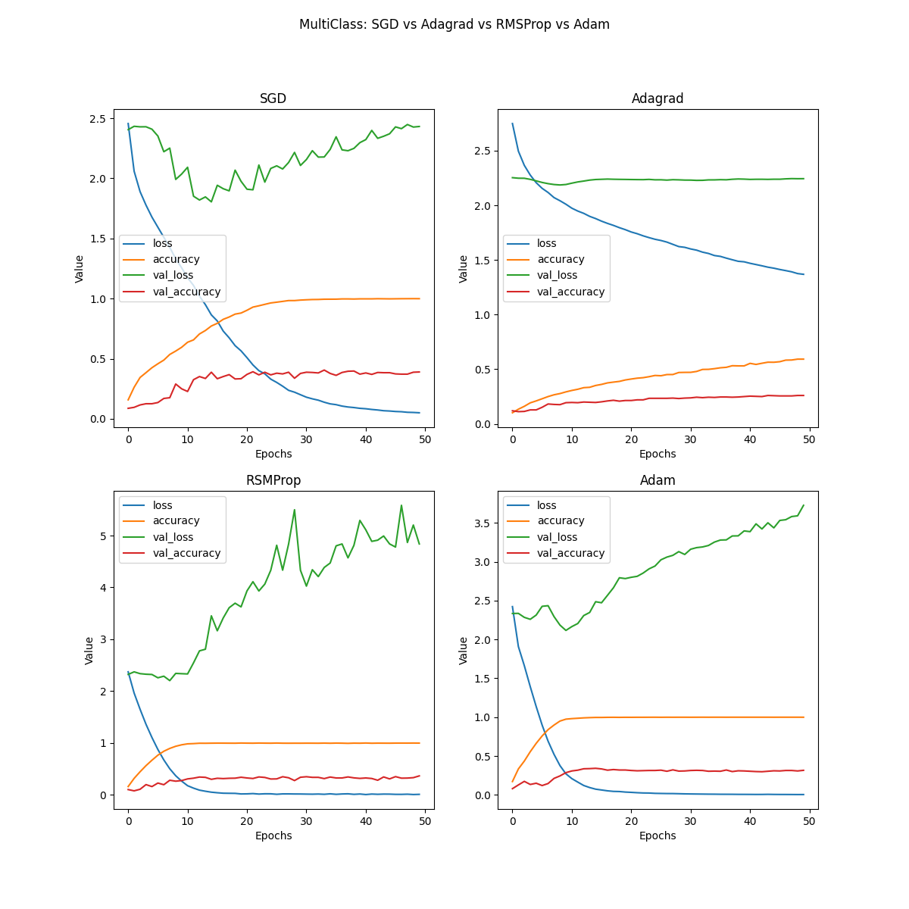1 additional conv + hidden layer 16 neurons

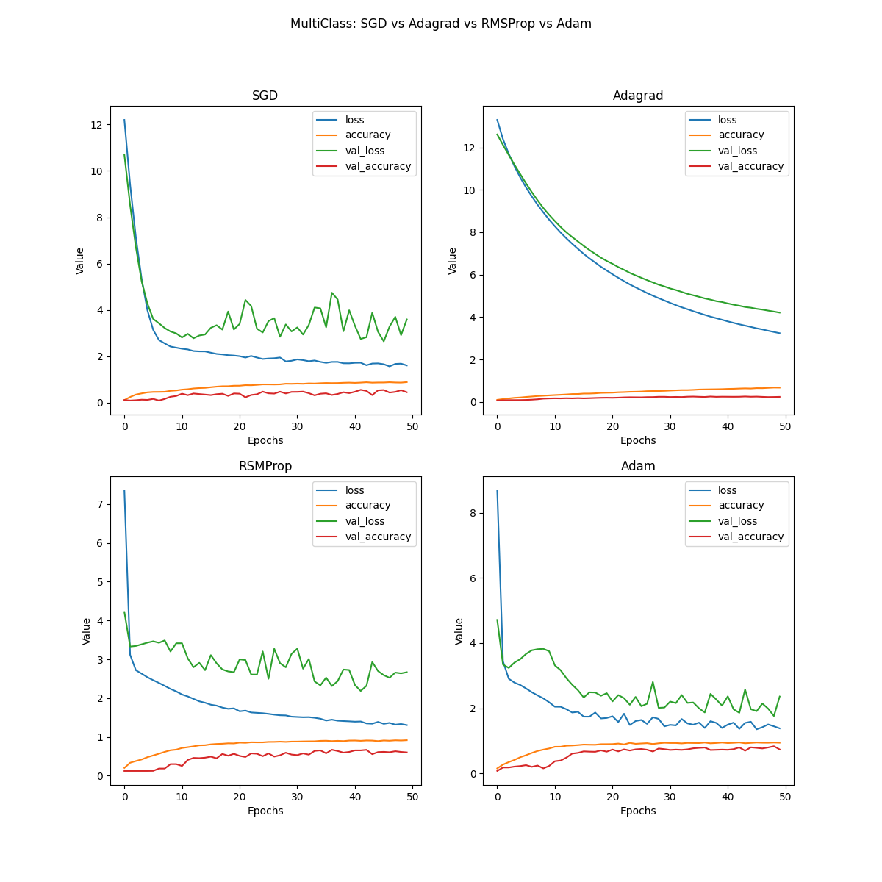1 additional conv + hidden layer 16 neurons with l1 reg

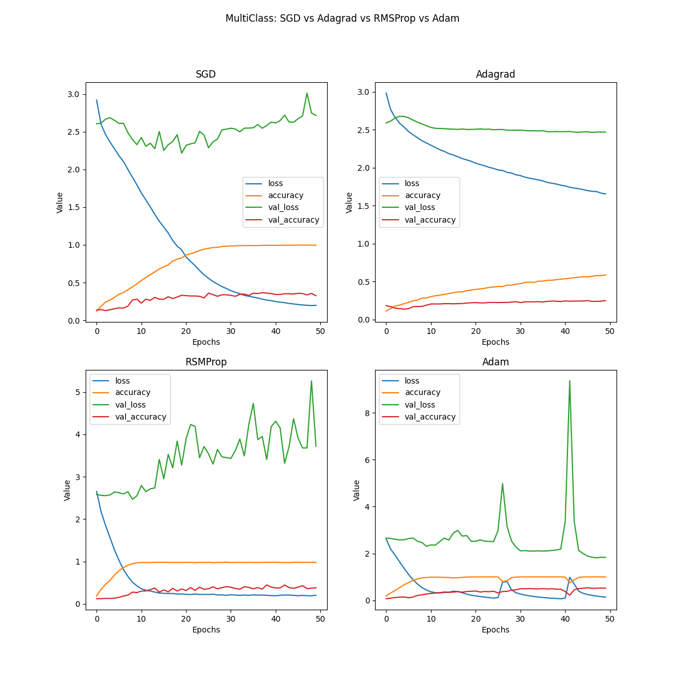1 additional conv + hidden layer 16 neurons with l2 reg

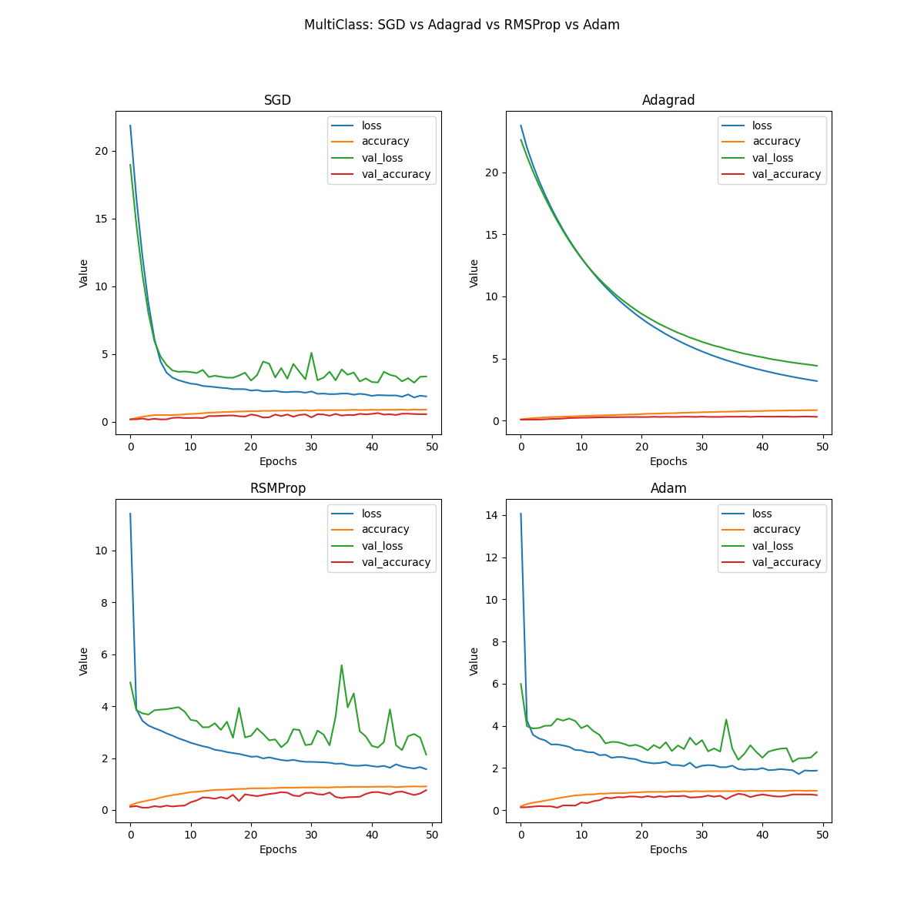1 additional conv + hidden layer 32 neurons with l1 reg

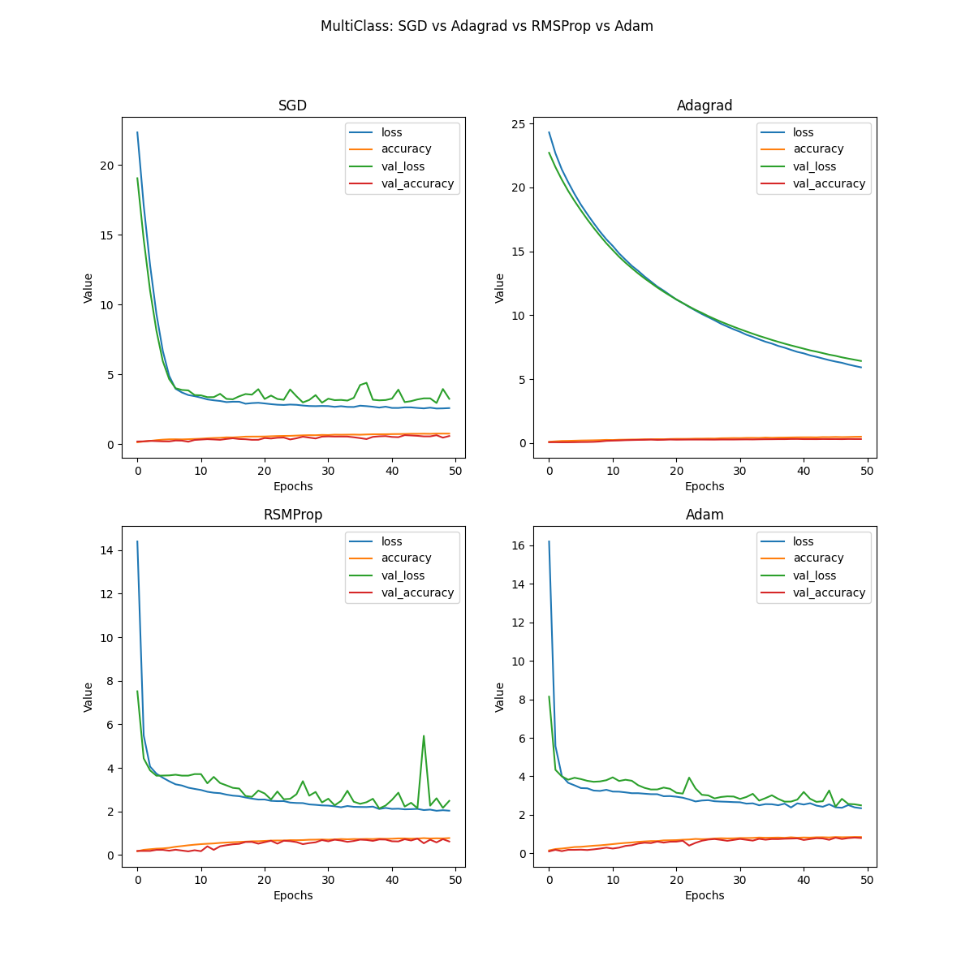1 additional conv + hidden layer 32 neurons with l1 reg + dropout 0.5

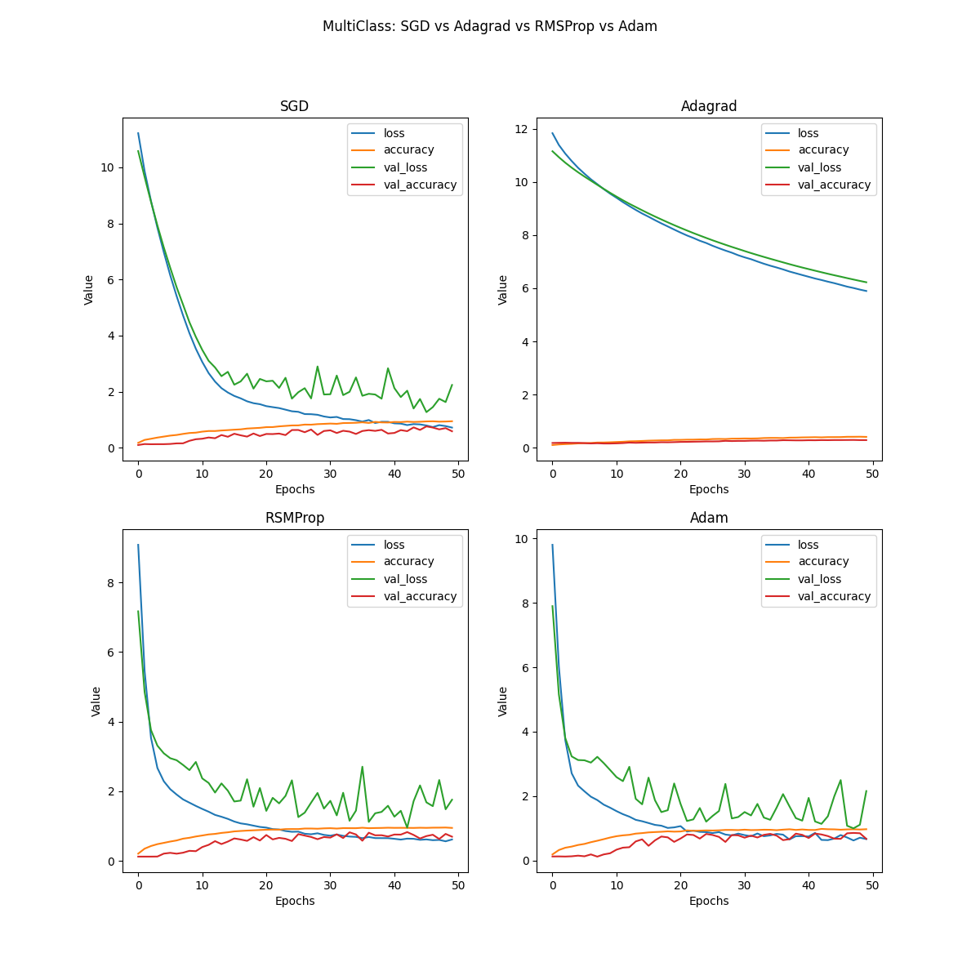2 additional conv + hidden layer 32 neurons with l1 reg

