**DI/FCT/NOVA**

**Mestrado Integrado em Engenharia Informática**

**Cloud Computing Systems**

**1st Semester, 2020/2021**

**Midterm Test (4/November/2020)**

1) The first cloud service provided by Amazon, the first cloud provider, was the Elastic Compute Cloud, a service that allowed clients to rent virtual machines to run their programs (often referred as IaaS). Discuss possible reasons for this fact. [In your reply consider the alternative types of cloud services that could have been offered, such as PaaS and SaaS]

|  |
| --- |

2) Consider you want to develop a reservation service similar to the one being developed in this course’s project. **NOTE:** t**he following questions must be answered considering this specific service – avoid generic comments. Specify your assumptions regarding the service, when relevant.**

a) Would it be simpler to develop your solution based om a PaaS platform or on a IaaS platform? Justify.

| PaaS simpler than Iaas, because…. / IaaS simpler than PaaS, because…. |
| --- |

b) Are there benefits of using a CDN in the context of this specific service? Justify.

| Yes, because… / No, because… |
| --- |

c) Azure functions allow to define functions activated through HTTP-triggers. Discuss the conditions under which it would be preferable to implement your service using this functionality (when compared with the more traditional solutions of using Azure App Service).

|  |
| --- |

3) Consider the pricing of Azure Blob Storage service, as presented next (separately for data storage and for operations).

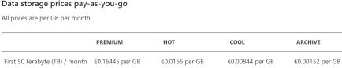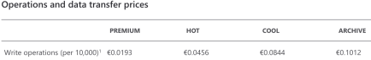Do you think the relative price difference between hot, cool and archive tiers for data storage and operations can be justified based on the resources used? Justify (given the techniques that can be used to provide reliable storage).

| Yes / No, because…. |
| --- |

4) The first generation of geo-replicated cloud databases adopted weak consistency models (in contrast with traditional SQL databases). Present reasons for such option.

|  |
| --- |

5) Azure Cosmos DB supports different consistency models: strong consistency, bounded staleness, session, consistent prefix and eventual. It has additional support for transactions and conditional updates.

a) Session consistency level provide (among other) the following guarantee: **Read your writes**: a read always reflects the writes executed in the session.

Although this seems the minimum an application would like to have, some consistency levels do not support it. Which consistency levels do not support this guarantee? Explain the reason why these consistency levels might fail to provide such guarantee.

|  |
| --- |

b) Cosmos BD defines the following service level agreements, regarding the Recovery Point Objective and the Recovery Time Objective.

Note: **Recovery time objective (RTO)** is the time until the system

DURABILITY (3) **What justifies these values?**

recovers from a disruptive event.

**Recovery point objective (RPO)** is the period of time for which updates might get lost in a failure.

Consider the values presented in the second line. Given these values, what is possible to conclude regarding the replication process for those 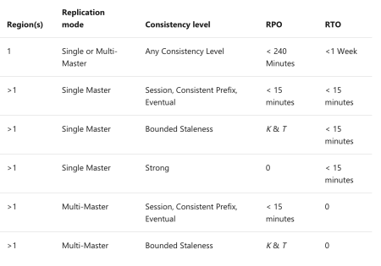

consistency levels? Justify. NOTE: specify whether replication is

synchronous or asynchronous and what are the implications of the values

15 minutes for RPO and RTO.

| **Cloud Computing System 20/21 – Nuno Preguiça – DI/FCT/NOVA / 5** |
| --- |

6) Redis supports several data types, including strings, lists and sets. Consider that in the project you are developing you intend to store in the Redis cache the reservation an entity has for a given day. Explain how you could Redis for such goal. In your reply, specify the data type you would use and explain the reason, the keys used to store information and how this information is accessed/updated when clients issue operations.

| Strings / Lists / Sets  Key:  How used: |
| --- |

7) Lambda@Edge is a Amazon service that allows to run Lambda functions in points of presence located very close to clients (e.g. in ISPs). What kind of service can better use this service – stateless services, stateful services, both. Justify.

| Stateless services, because… / Stateful services, because… / Both, because… |
| --- |