**Engenharia Informática (FCT/UNL)**

2007/2008

**Interacção Pessoa-Máquina**

**Exam**

January 28, 2008

Duration: 2h

1) Explain the importance of task analysis as a first step in the user-centered design process.

2) Briefly describe three techniques that can be used to collect information during the task analysis.

3) In the scope of interface design, comment the sentence: "Not all the knowledge needed for a specific conduct has to be in the head."

4) Explain the "Interaction Framework" proposed by Abowd & Beale.

5) Identify the main reasons that make the paper prototypes appropriate during the early stages of interface design.

6) Which of the following problems are least likely to be revealed by testing a paper prototype?

a) The help menu is not in the proper position.

b) The users do not know the term "algorithm".

c) The toolbar buttons are too small.

d) The system does not provide a specific essential functionality.

7) Describe the formal process of heuristic evaluation (including the consolidation of the evaluations of the several experts).

8) The use of metaphors can facilitate the communication of the conceptual model. However, the use of metaphors may also cause some problems. Indicate which ones and justify.

9) Command-based interfaces violate some of the usability heuristics.

a) Indicate the two most relevant ones and justify your answer.

b) Identify the advantages of this interaction style.

10) Identify the graphic design problems in the following Web page.

Purple Yellow

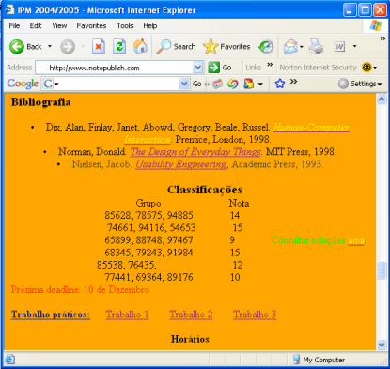

Blue Purple Orange background Red Green Yellow

The remaining text is in black.

**Good work!**