

**Interação Pessoa-Máquina  
Human-Computer Interaction**

**2020/2021**

**Samucar Website**



Stage 1: Project Proposal



**By: Lab class Nº** P3

53193, Afonso Nascimento **Group Nº** 18

53298, Alexandre Correia

52281, Diogo Gomes **Professor:**

52370, Pedro Ferreira Teresa Romão

October 12, 2020

## Project Description

Describe the problem you will try to solve during the project. You should try to play the role of the users and describe their needs and difficulties – not the solutions for their problems.

Mobility is an essential factor in today’s society, therefore almost everyone feels the need to have a vehicle.

To answer this necessity, Samucar, as an automotive stand, offers a large range of vehicles but their current website has some faults, such as: the search tool is not very intuitive, the information about each vehicle is not very well organized and the whole interface has a quite old design in general. Overall this interface is not the most efficient and user friendly.

To fix this issue, our project will focus on the redesign of their website and the development of new useful features.

## Target Users

Shortly, characterize the target user population

This project aims to target the general driving population in the lookout for a vehicle.

Samucar currently has around 90.000 followers, as shown in the next plot, and intends to keep its base of users growing with a new interface design.

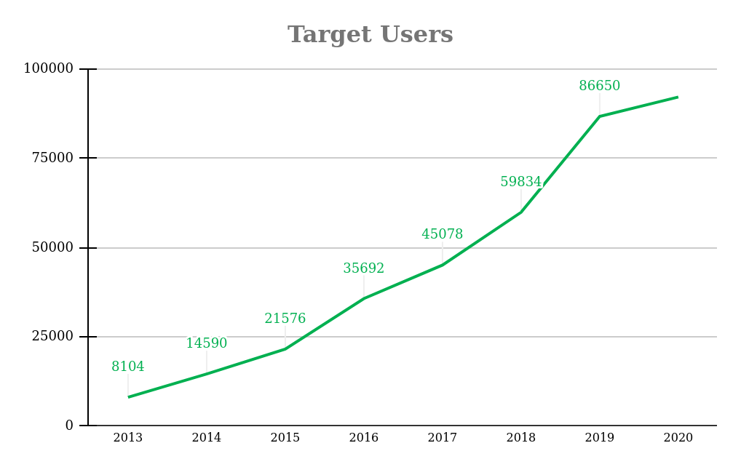

## Project Goal

Describe the main goal of your project and a possible solution to the problem. You are not absolutely committed to this solution. You can modify your solution during the project development, if the evaluation procedures recommend a different solution.

As mentioned previously, the current Samucar website has some faults, and so, with this project we want to help the users/customers to quickly and efficiently navigate through the website and discover vehicles they might be interested in.

To achieve this goal we will redesign the interface, improve the existing functionalities (e.g. the search tool) and add new functionalities (e.g. evaluation of the user/customer’s vehicle, ask for credit).

## Existing solution

In case it exists, identify at least one application that competes with your proposed project, indicating what are the positive and negative aspects about that design. Your project is supposed to fix those wrong design issues.

As already stated, the Samucar dealership already has a website and is willing to improve it.

Our work doesn't intend to compete with their existing solution but instead to become an improved version. The existing solution contains positive aspects that we would like to maintain and some negative design flaws that we intend to improve upon. These aspects and their respective descriptions are presented in the following table:

| **Positive aspects** | **Negative aspects** |
| --- | --- |
| Current loading page mechanism *The logo while the page is loading* | Search tool *It is missing the possibility to search by name (the user should be able to manually type and search)* |
| Information presentation *Currently all the necessary information is being shown* | Credit simulator *It doesn’t exist* |
|  | Uploading cars *It is a manual and very hard process to upload each car* |
|  | Retake car page *It is really hard to see which informations are being asked and not all the required information for the retake is being asked* |
|  | Car details page *The information is not organized and there is a bug while displaying a specific car, where the filter is still shown where it shouldn’t* |